Test Case: tc002_SPX_Dev5_Crear_Requisicion_Spot_Tipo_Cobro_Project
Step 1 - Enter username and password and click to button Enter: Credentials Entered
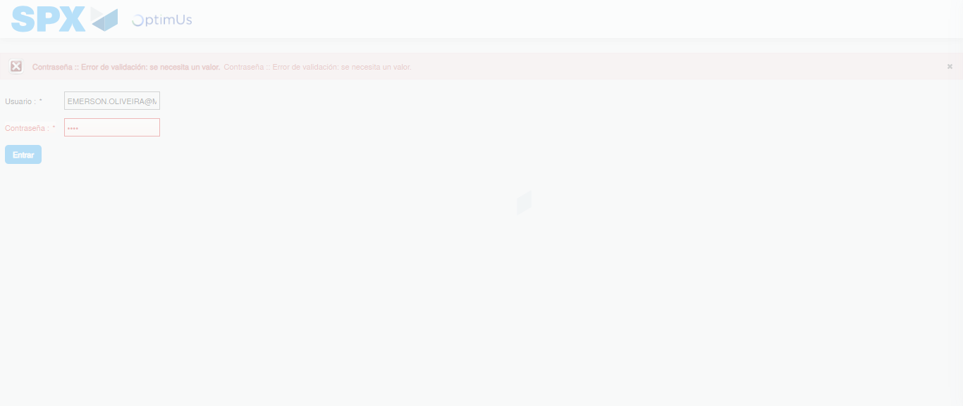Image file-name: QC_Testing-tc002_SPX_Dev5_Crear_Requisicion_Spot_Tipo_Cobro_Project-1784228992531

Step 2 - Select to UEN and Access to Spot Buy Requisitions : UEN Correctly selected and Correct access
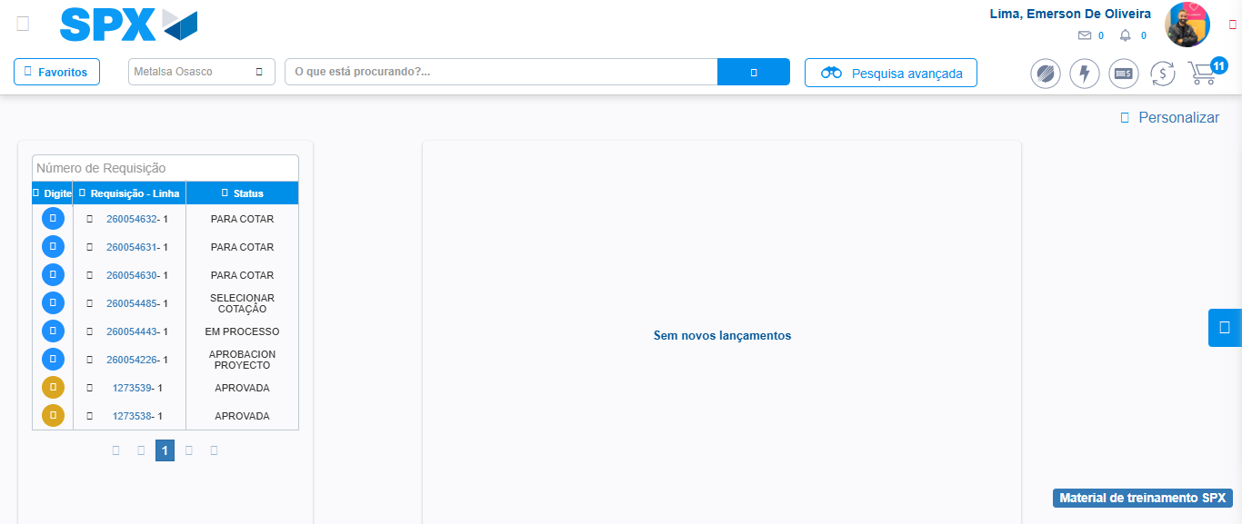Image file-name: QC_Testing-tc002_SPX_Dev5_Crear_Requisicion_Spot_Tipo_Cobro_Project-1784229018924

Image file-name: QC_Testing-tc002_SPX_Dev5_Crear_Requisicion_Spot_Tipo_Cobro_Project-1784229021405

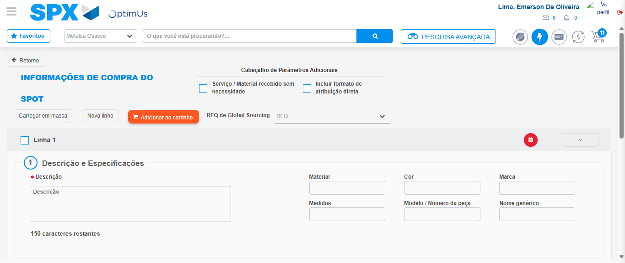Image file-name: QC_Testing-tc002_SPX_Dev5_Crear_Requisicion_Spot_Tipo_Cobro_Project-1784229057398

Step 3 - Data Capture Spot Buy Requisition: Data captured correctly
Image file-name: QC_Testing-tc002_SPX_Dev5_Crear_Requisicion_Spot_Tipo_Cobro_Project-1784229057666

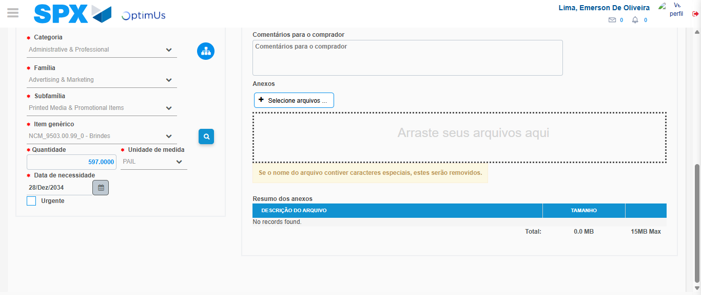Image file-name: QC_Testing-tc002_SPX_Dev5_Crear_Requisicion_Spot_Tipo_Cobro_Project-1784229071438

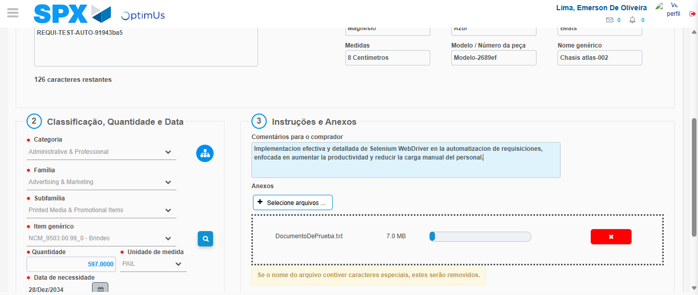Image file-name: QC_Testing-tc002_SPX_Dev5_Crear_Requisicion_Spot_Tipo_Cobro_Project-1784229072480

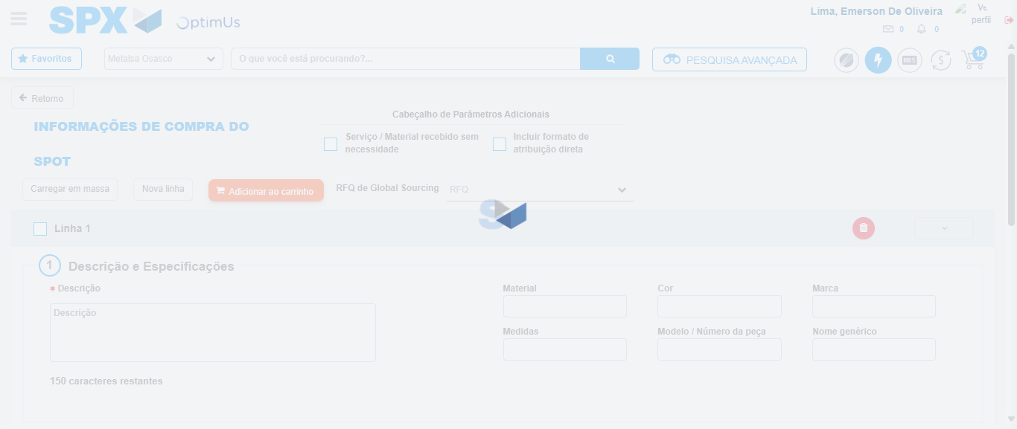Image file-name: QC_Testing-tc002_SPX_Dev5_Crear_Requisicion_Spot_Tipo_Cobro_Project-1784229074635

Step 7 - Return to Main Page SPX : Return to Main Page SPX
Image file-name: QC_Testing-tc002_SPX_Dev5_Crear_Requisicion_Spot_Tipo_Cobro_Project-1784229018924

Image file-name: QC_Testing-tc002_SPX_Dev5_Crear_Requisicion_Spot_Tipo_Cobro_Project-1784229021405

Image file-name: QC_Testing-tc002_SPX_Dev5_Crear_Requisicion_Spot_Tipo_Cobro_Project-1784229057398

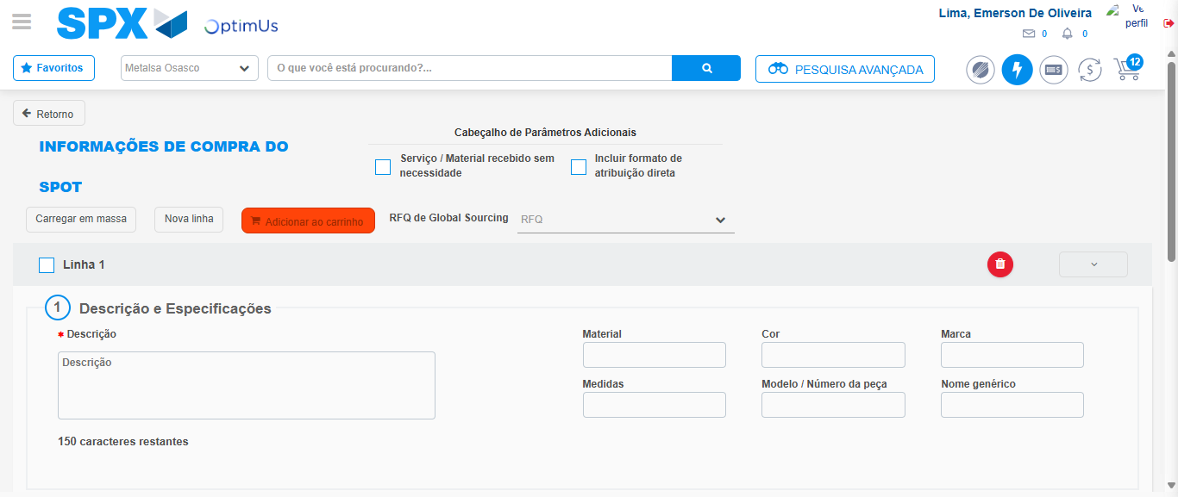Image file-name: QC_Testing-tc002_SPX_Dev5_Crear_Requisicion_Spot_Tipo_Cobro_Project-1784229076938

Image file-name: QC_Testing-tc002_SPX_Dev5_Crear_Requisicion_Spot_Tipo_Cobro_Project-1784229077151

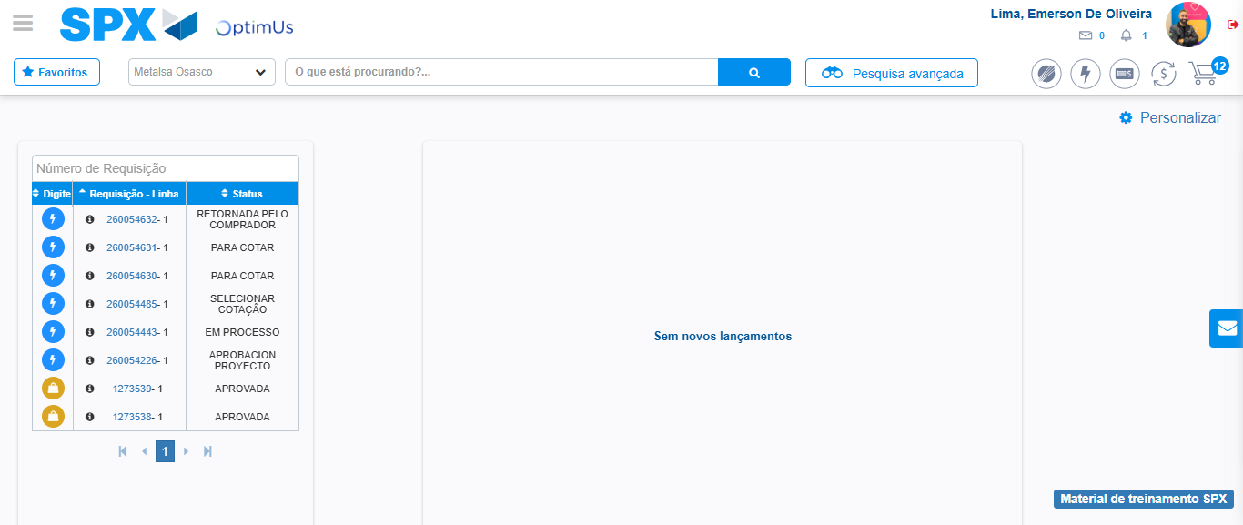Image file-name: QC_Testing-tc002_SPX_Dev5_Crear_Requisicion_Spot_Tipo_Cobro_Project-1784229098258

Step 8 - Log Out : Log Out SPX
Image file-name: QC_Testing-tc002_SPX_Dev5_Crear_Requisicion_Spot_Tipo_Cobro_Project-1784229098512

